Week 2 Cybersecurity Internship Report
Name: Lubanzi Fihla lubhilubanzi@gmail.com +27 78 973 2604
Batch: B083
Program: NetworkWalks Cybersecurity Internship

Disclaimer
This report was prepared for educational purposes as part of the NetworkWalks Cybersecurity Internship Program. All activities were performed in a controlled lab environment and publicly available information sources were used during reconnaissance activities.

Executive Summary
This report documents the completion of Week 2 cybersecurity activities involving footprinting using theHarvester and network scanning using Zenmap.
The objective was to understand how cybersecurity professionals perform reconnaissance and network discovery to identify publicly available information and active hosts within a network.
The practical exercises provided hands-on exposure to Open Source Intelligence (OSINT), host discovery, network enumeration, and use of industry-standard tools such as theHarvester, Zenmap, and Nmap.

Module 1: Footprinting with theHarvester

Objective
The objective of this activity was to gather publicly available information about a target domain using passive reconnaissance techniques.

Tool Used
- Kali Linux
- theHarvester

Commands Executed
theHarvester -d microsoft.com -l 1000 -b baidu
theHarvester -d microsoft.com -l 50 -b all

Results
TheHarvester successfully collected publicly available information related to the domain microsoft.com.
The scan identified numerous hostnames and subdomains associated with Microsoft services.
Examples discovered include:
- learn.microsoft.com
- support.microsoft.com
- developer.microsoft.com
- outlook.microsoft.com
- copilot.microsoft.com
- opensource.microsoft.com
The scan demonstrated how publicly available information can be collected without directly interacting with target systems.

Evidence
Figure 1: theHarvester Task 1
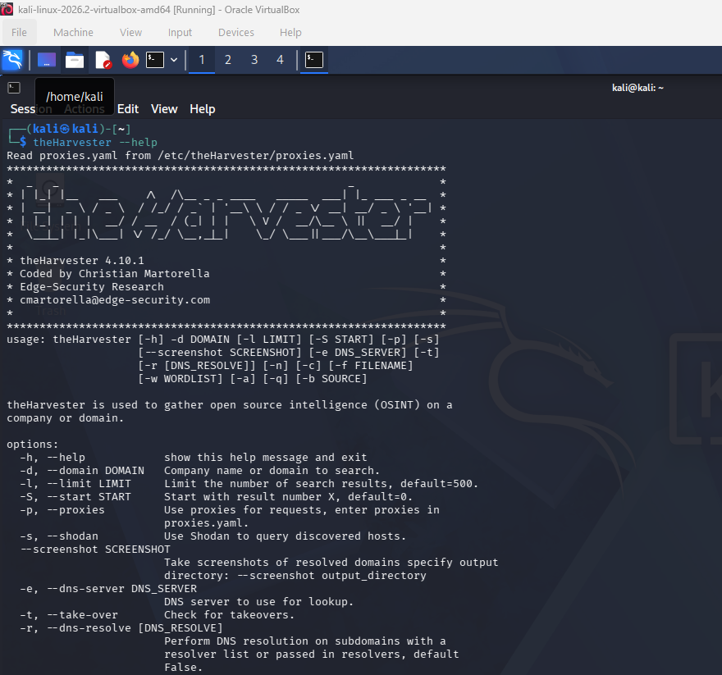
Figure 2: theHarvester Task 2
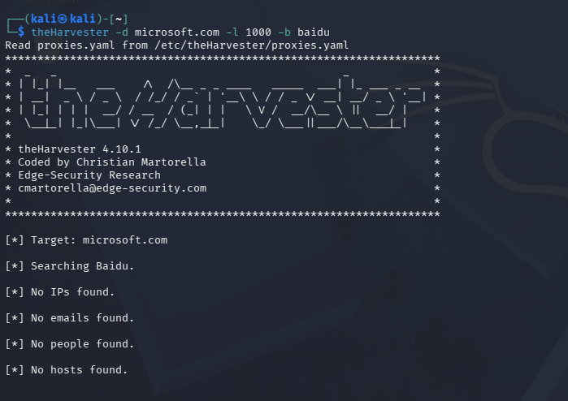

Module 2: Network Scanning with Zenmap

Objective
The objective of this activity was to identify active hosts within the virtual lab network.

Tool Used
- Zenmap
- Nmap
- Kali Linux

Network Details
Target Network:
10.0.0.0/24
Scan Profile:
Ping Scan

Scan Results
The Zenmap scan successfully identified active hosts on the network.

Live Hosts Discovered
10.0.0.1
10.0.0.2

Number of Active Hosts
2

MAC Address Identified
52:54:00:12:35:00

Observations
The scan confirmed connectivity between the virtual machine and the configured NAT network. Zenmap successfully identified devices responding to network probes and provided visibility into network topology.

Evidence
Figure 3: IP Address Configuration
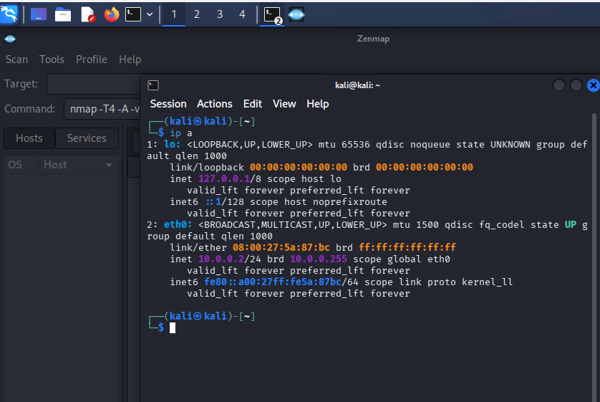
Figure 4: Zenmap Scan Results
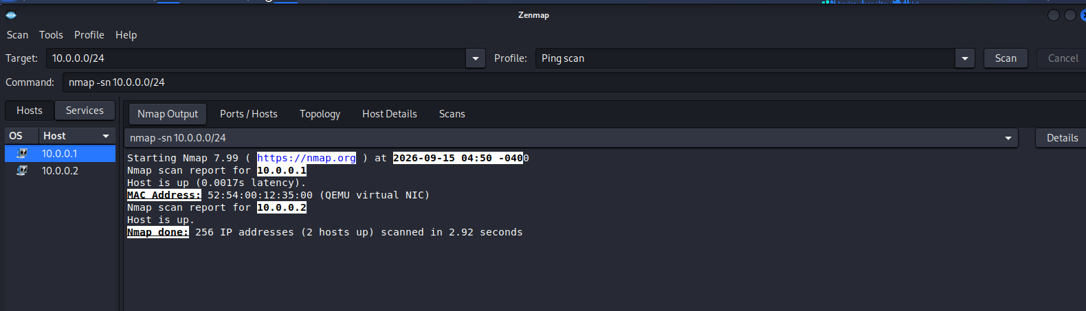
Figure 5: Network Topology
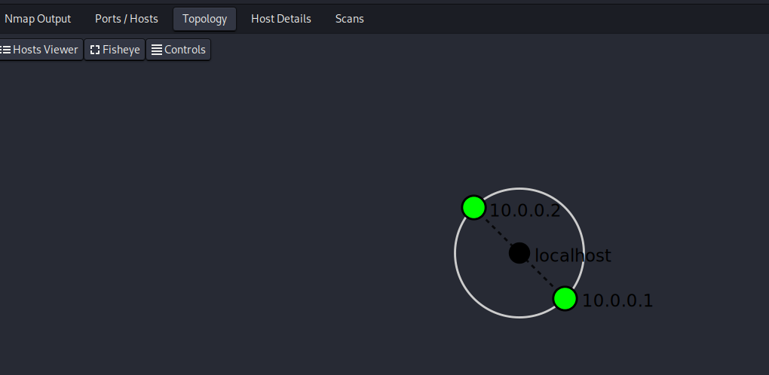

Risk Analysis
Information disclosed through public sources can assist attackers during the reconnaissance phase of a cyberattack.
Publicly exposed subdomains, services, and infrastructure information can provide valuable intelligence that may be used to identify potential attack targets.
Regular monitoring of exposed assets is essential to reduce organizational risk.

Recommendations
- Monitor publicly accessible assets regularly.
- Review exposed domains and services.
- Implement asset management practices.
- Conduct periodic security assessments.
- Limit unnecessary information exposure where possible.

Lessons Learned
During this project I learned:
- Footprinting techniques
- Open Source Intelligence (OSINT)
- Passive Reconnaissance
- Host Discovery
- Network Enumeration
- Use of theHarvester
- Use of Zenmap
- Nmap Scanning Techniques

Conclusion
The Week 2 activities provided practical exposure to reconnaissance and network scanning methodologies used in cybersecurity assessments.
TheHarvester demonstrated how publicly available information can be collected from open sources, while Zenmap provided visibility into active devices within the lab environment.
The project strengthened my understanding of information gathering, network discovery, and cybersecurity reconnaissance processes.
-End-

